Test Samples of My GeoVision Mobel — Image-Based Geo-Location Predictor

Test Sample - 1
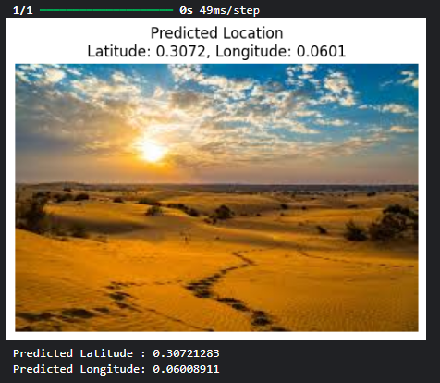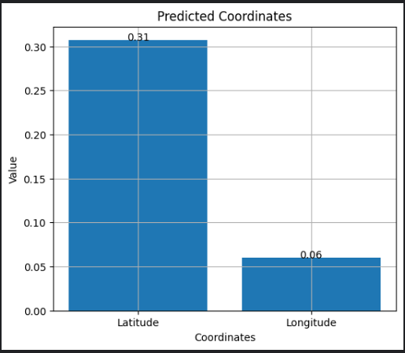

Test Sample - 2
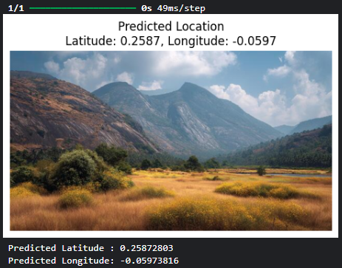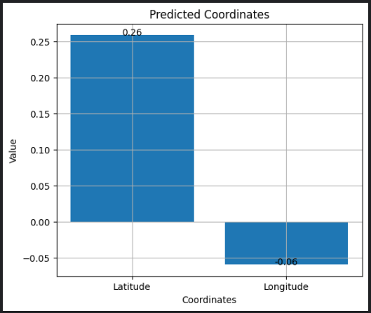

Test Sample – 3
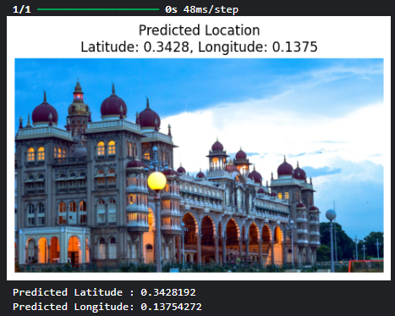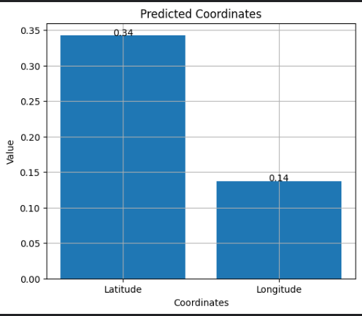
Test Sample – 4
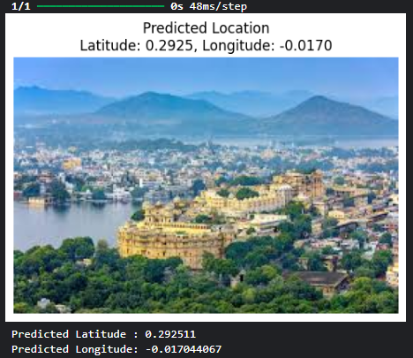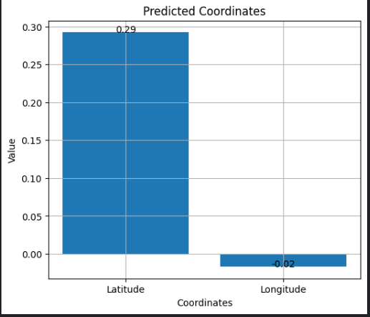

Test Sample – 5
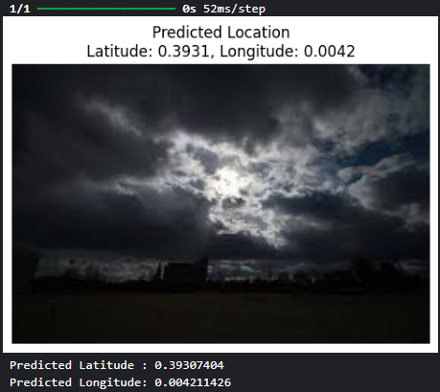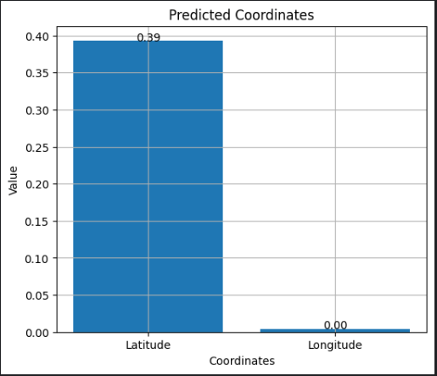

Test Sample – 6
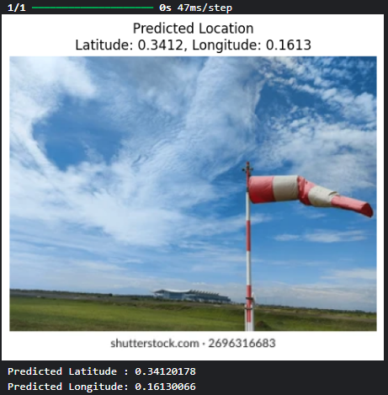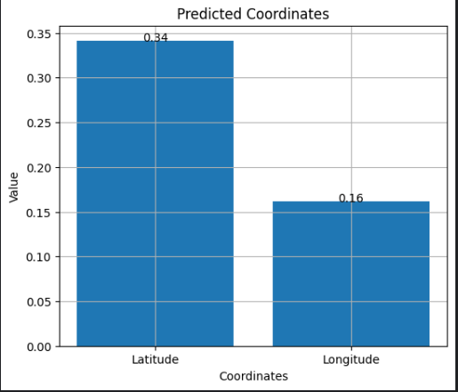

Test Sample – 7
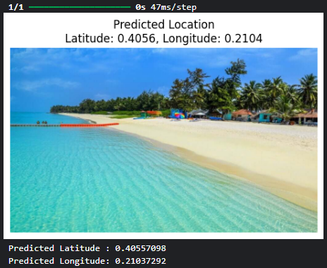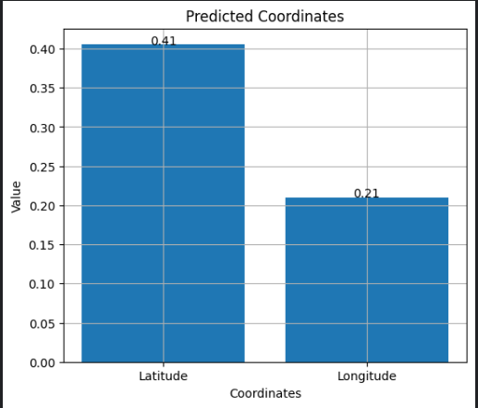

Test Sample – 8
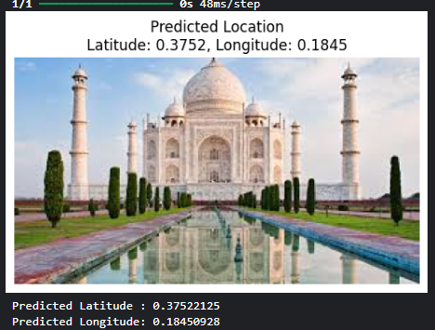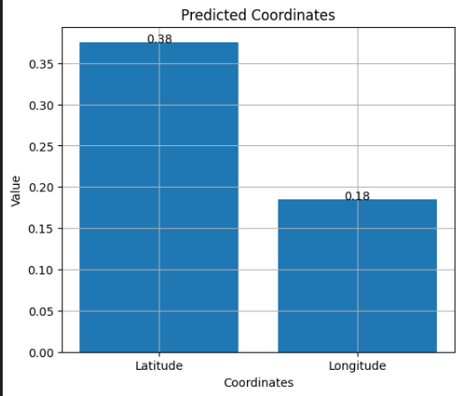

Test Samples Code
Code:
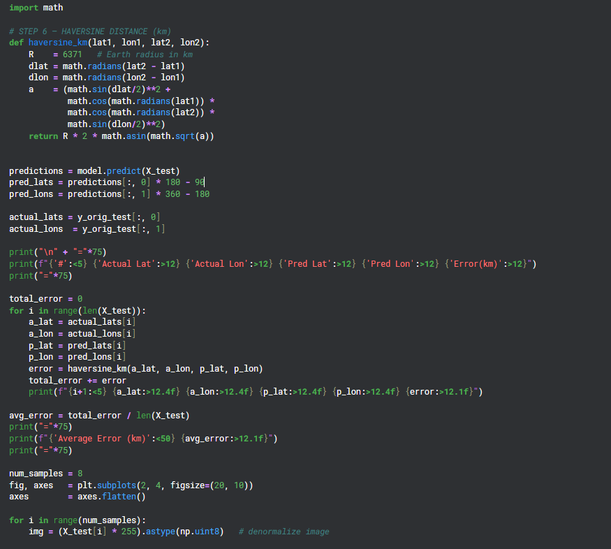
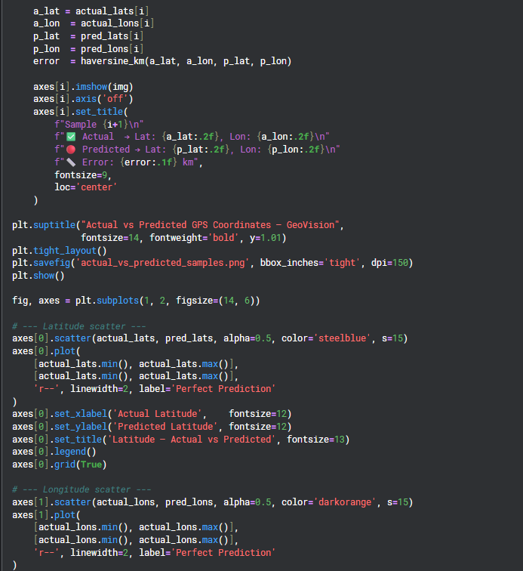
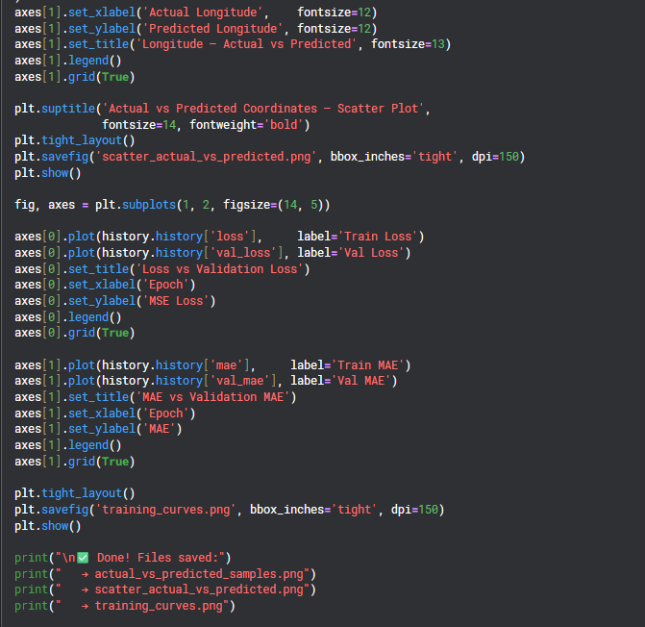

Description:
Here's a complete explanation of every part of this code:

Part 1 — Haversine Distance Function
def haversine_km(lat1, lon1, lat2, lon2):
R = 6371
dlat = math.radians(lat2 - lat1)
dlon = math.radians(lon2 - lon1)
a = (math.sin(dlat/2)**2 +
math.cos(math.radians(lat1)) *
math.cos(math.radians(lat2)) *
math.sin(dlon/2)**2)
return R * 2 * math.asin(math.sqrt(a))
What it does: Calculates the real-world distance in kilometers between two GPS points on Earth's curved surface.
Why we need it: Simple subtraction like actual_lat - pred_lat gives a meaningless number. The Earth is a sphere, not a flat surface. For example:
1° of latitude = always ~111 km
1° of longitude = 111 km at equator
= 0 km at the poles
Haversine handles this correctly using trigonometry.
Breaking down each line:
R = 6371 # Earth's radius in km — fixed constant

dlat = math.radians(lat2 - lat1)
dlon = math.radians(lon2 - lon1)
# Convert degree difference to radians
# because math.sin() and math.cos() work in radians not degrees

a = (math.sin(dlat/2)**2 +
math.cos(math.radians(lat1)) *
math.cos(math.radians(lat2)) *
math.sin(dlon/2)**2)
# This is the core Haversine formula
# 'a' represents the square of half the chord length

return R * 2 * math.asin(math.sqrt(a))
# Converts 'a' back into km distance on Earth's surface

Part 2 — Getting Predictions & Converting Back
predictions = model.predict(X_test)
pred_lats = predictions[:, 0] * 180 - 90
pred_lons = predictions[:, 1] * 360 - 180

actual_lats = y_orig_test[:, 0]
actual_lons = y_orig_test[:, 1]
What it does: Gets the model's predictions and converts them back to real GPS coordinates.
Why we need it: The model outputs values between [0, 1] because of the sigmoid activation. We need to reverse the normalization we did during preprocessing.
Forward (preprocessing):
lat → (lat + 90) / 180 → [0, 1]
lon → (lon + 180) / 360 → [0, 1]

Reverse (here):
pred * 180 - 90 → real latitude [-90, +90]
pred * 360 - 180 → real longitude [-180, +180]
y_orig_test is the copy of real GPS coordinates we saved before normalization — so actual values are always the true GPS from the dataset.

Part 3 — Comparison Table
print(f"{'#':<5} {'Actual Lat':>12} {'Actual Lon':>12}
{'Pred Lat':>12} {'Pred Lon':>12} {'Error(km)':>12}")

for i in range(len(X_test)):
error = haversine_km(a_lat, a_lon, p_lat, p_lon)
total_error += error
print(f"{i+1:<5} {a_lat:>12.4f} ...")

avg_error = total_error / len(X_test)
What it does: Prints a clean formatted table showing every test image with 5 columns — actual lat, actual lon, predicted lat, predicted lon, and km error.
Why we need it: This is the most honest evaluation of my model. Instead of abstract numbers like MAE = 0.14, you see real-world output like:
# Actual Lat Actual Lon Pred Lat Pred Lon Error(km)
===================================================================
1 34.2848 -118.7469 29.4016 -6.1074 10011.0
2 52.3162 4.8083 24.8845 3.6113 3051.9
What the formatting symbols mean:
{i+1:<5} # left-align, 5 characters wide
{a_lat:>12.4f} # right-align, 12 wide, 4 decimal places

Part 4 — 8 Sample Image Visualizations
num_samples = 8
fig, axes = plt.subplots(2, 4, figsize=(20, 10))

for i in range(num_samples):
img = (X_test[i] * 255).astype(np.uint8)
axes[i].imshow(img)
axes[i].set_title(
f"✅Actual → Lat: {a_lat:.2f}, Lon: {a_lon:.2f}\n"
f"🔴 Predicted → Lat: {p_lat:.2f}, Lon: {p_lon:.2f}\n"
f"📏 Error: {error:.1f} km"
)

plt.savefig('actual_vs_predicted_samples.png', dpi=150)
What it does: Creates a 2×4 grid of 8 test images, each showing the actual GPS, predicted GPS, and km error as the title.
Why we need it: Pure numbers in a table are hard to understand visually. Seeing the actual photo alongside coordinates makes it immediately clear — for example, a beach photo predicted to be in the wrong ocean is instantly obvious. This is also my best sample_outputs file for GitHub.
Line by line:
plt.subplots(2, 4)
# Creates 2 rows × 4 columns = 8 image slots

img = (X_test[i] * 255).astype(np.uint8)
# X_test was normalized to [0,1] for the model
# Multiply by 255 to get back normal pixel values
# for correct color display

plt.savefig(..., dpi=150)
# Save as PNG file — dpi=150 makes it sharp and clear
# bbox_inches='tight' removes extra whitespace

Part 5 — Scatter Plot
axes[0].scatter(actual_lats, pred_lats,
alpha=0.5, color='steelblue', s=15)
axes[0].plot(
[actual_lats.min(), actual_lats.max()],
[actual_lats.min(), actual_lats.max()],
'r--', linewidth=2, label='Perfect Prediction'
)
What it does: Plots every test sample as a dot — X axis is actual coordinate, Y axis is predicted coordinate. The red dashed diagonal line represents perfect prediction.
Why we need it: If the model was perfect, every dot would sit exactly on the red diagonal line. The further dots are from that line, the worse the prediction.
Dots close to red line = good predictions
Dots scattered randomly = poor predictions (what yours shows)
What alpha=0.5 means: Makes dots semi-transparent so overlapping points are visible — without this, overlapping dots hide each other.
Two separate plots — latitude and longitude:
# Latitude plot → steelblue color
# Longitude plot → darkorange color
# Kept separate because they have different ranges
# lat: -90 to +90
# lon: -180 to +180

Part 6 — Training Curves
axes[0].plot(history.history['loss'], label='Train Loss')
axes[0].plot(history.history['val_loss'], label='Val Loss')

axes[1].plot(history.history['mae'], label='Train MAE')
axes[1].plot(history.history['val_mae'], label='Val MAE')

plt.savefig('training_curves.png', dpi=150)
What it does: Plots how loss and MAE changed across every epoch during training — both for training data and validation data.
Why we need it: These curves tell me the health of your training:
Pattern | Meaning
Both curves going down together | Healthy training
Train loss down, val loss flat | Overfitting
Both curves flat from early on | Not enough data
Val loss lower than train loss | Good generalization
In my case the curves showed val loss plateauing at epoch 4 — which directly told us the 1001-image limit was the bottleneck.

Part 7 — Save All Files
plt.savefig('actual_vs_predicted_samples.png', bbox_inches='tight', dpi=150)
plt.savefig('scatter_actual_vs_predicted.png', bbox_inches='tight', dpi=150)
plt.savefig('training_curves.png', bbox_inches='tight', dpi=150)
What it does: Saves all three plots as PNG image files in my Kaggle working directory.
Why we need it: These saved files are my sample_outputs for GitHub. Anyone visiting my repo sees real evidence of your model working — not just code.

Test Samples of Dataset

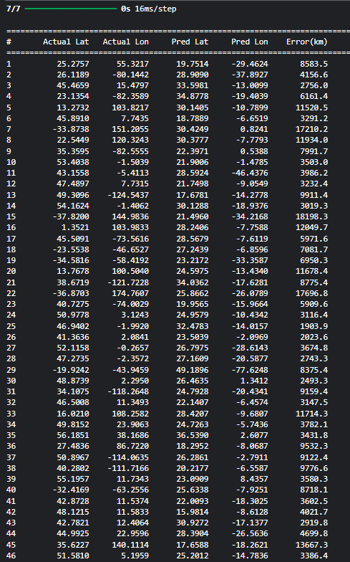
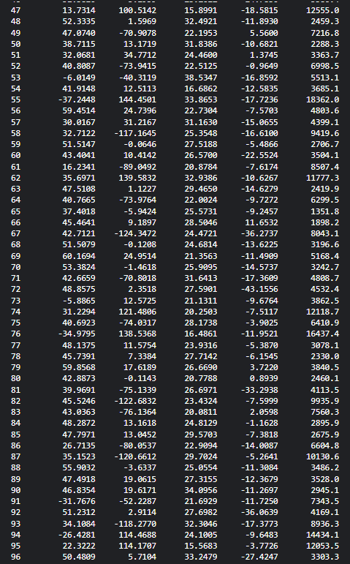

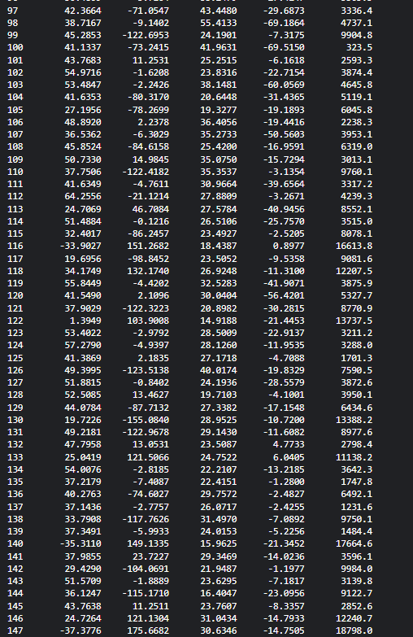

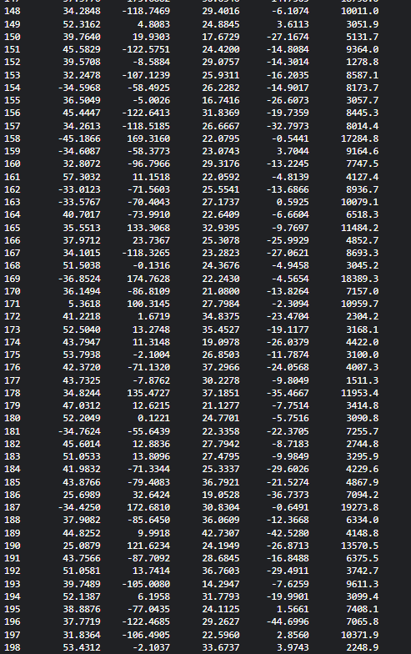
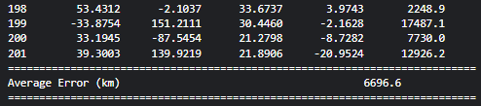

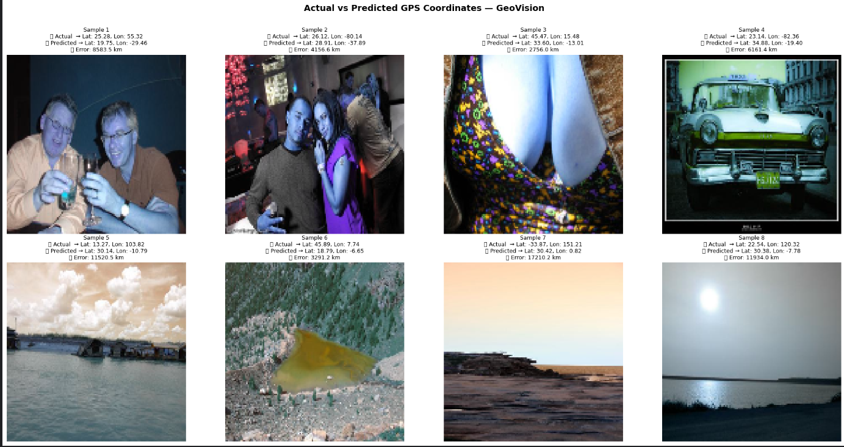

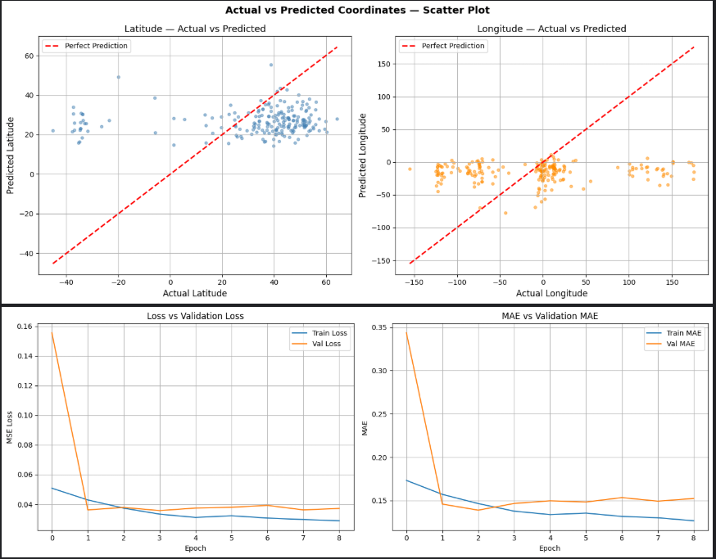
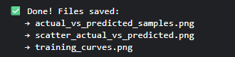

Mistakes in my Model
Why Is the Error So High?
It is NOT an AlexNet inspired model issue alone. It is a combination of 5 reasons:

1. Biggest Reason — Only 1001 Images (Data Starvation)
I trained on 1001 images
Earth has 510 million km² of surface area

That means each image "covers" ~510,000 km² on average
So errors of 5000-10000 km are mathematically expected
Dataset Size | Expected Error
1,001 images (yours) | 3,000 – 18,000 km
50,000 images | 500 – 2,000 km
500,000+ images | 50 – 500 km
4.2M images (full dataset) | Much better

2. Only 1 Shard Out of Many
python
# I only loaded shard_24.msg
# The full dataset has hundreds of shards
# I used less than 0.02% of available data

3. Training From Scratch — No Prior Visual Knowledge
My model starts with completely random weights and tries to learn geography from zero. It has never seen what a mountain, ocean, or city looks like before training begins.
Random weights → learns from 800 images → tries to predict entire Earth
= Mission impossible with this little data
This is exactly why Transfer Learning (which I plan to do next) is the right move. A pretrained model already knows what landscapes, buildings, and nature look like from ImageNet training on millions of images.

4. MSE Loss Treats All Errors Equally
python
# Your loss function
loss = 'mse'

# Problem:
# Being wrong by 10° lat near equator = ~1100 km
# Being wrong by 10° lat near poles = ~500 km
# MSE doesn't understand this geographic reality
The model optimizes MSE mathematically but has no concept of actual km distance.

5. Geographic Imbalance in Dataset
Since the dataset comes from Flickr, it is heavily biased toward USA and Western Europe. When the model sees an image from Australia or South America (like row 158 with actual lat -45.18, lon 169.31), it has almost no training examples from that region — so it predicts wildly wrong (error: 17,284 km).

